

**New CE Baseline Assessment**

Help document

# Introduction

|  |  |  |
| --- | --- | --- |
| **The Current CE baseline format is being replaced with a new version**   * The Assessment time reduces from 2 hours to 45 minutes * The new assessment format is divided into 9 sections, details of which can be found in this document |  | **This guide covers the following sections**   * Structure of the assessment * Types of questions to expect during the assessment |

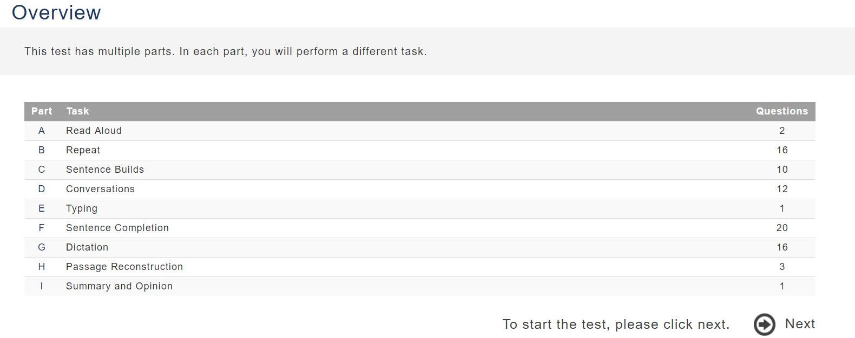

# Part A: Read aloud

|  |  |  |
| --- | --- | --- |
| **Task Description:**  Read a passage aloud for 30 seconds.  **Number of questions:** 2  **Time allotted:** 2 minutes |  | **Example**  Australia is a very large country. It is the sixth largest country in the world. It is also a continent and is sometimes called the 'island continent'.  It is surrounded by two oceans. Most of Australia is a desert so it is very flat and dry, but it also has rain forests and mountains. It is home to many different kinds of animals. |

***\*Failure to complete the entire passage in 30 seconds will not be counted against you***

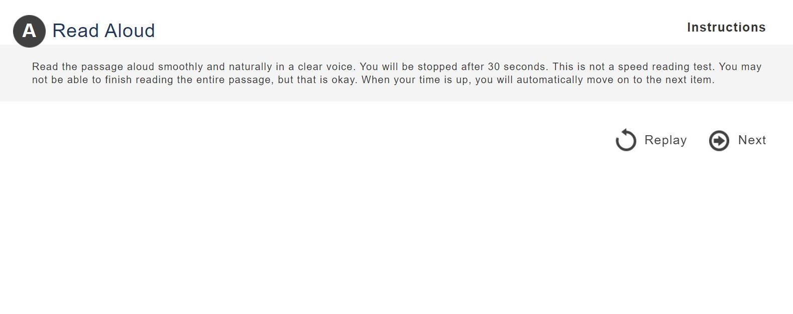

# Part B: Repeats

|  |  |  |
| --- | --- | --- |
| **Task Description:**  Listen to a sentence and repeat the sentence word-for-word. The sentences are presented in approximate order of increasing difficulty.  **Number of questions:** 16 |  | **Example**   1. He’s a great teacher. 2. It’s not too late to change your mind. 3. People know how easy it is to get lost in thought.   **Time allotted:** 5 minutes |

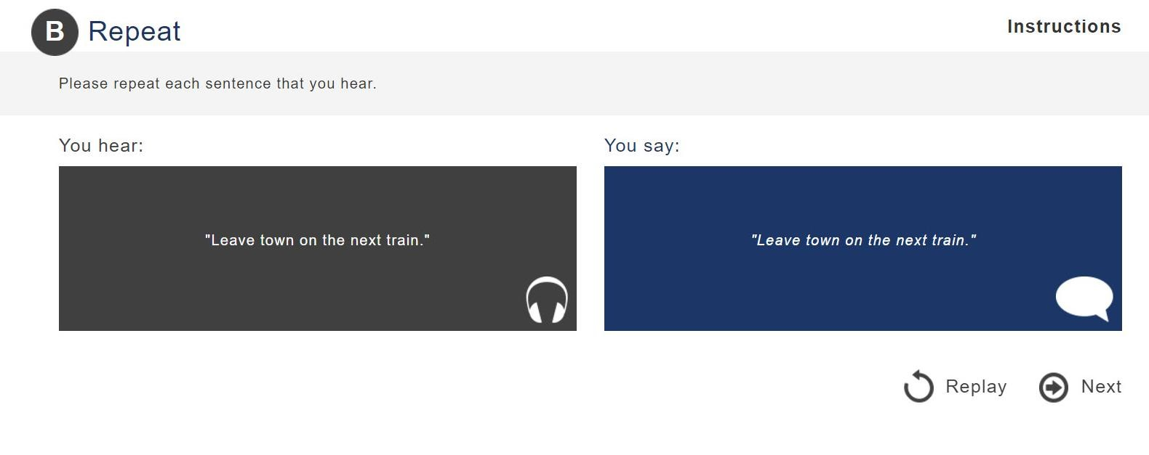

# Part C: Sentence Builds

|  |  |  |
| --- | --- | --- |
| **Task Description:**  Listen to a group of three short phrases presented in random order and then rearrange the phrases to make a sentence.  **Number of questions:** 10 |  | **Example**   1. my boss/to London/moved 2. of your family/any pictures/do you have 3. to their leader/listened carefully/the young men   **Time allotted:** 3 minutes |

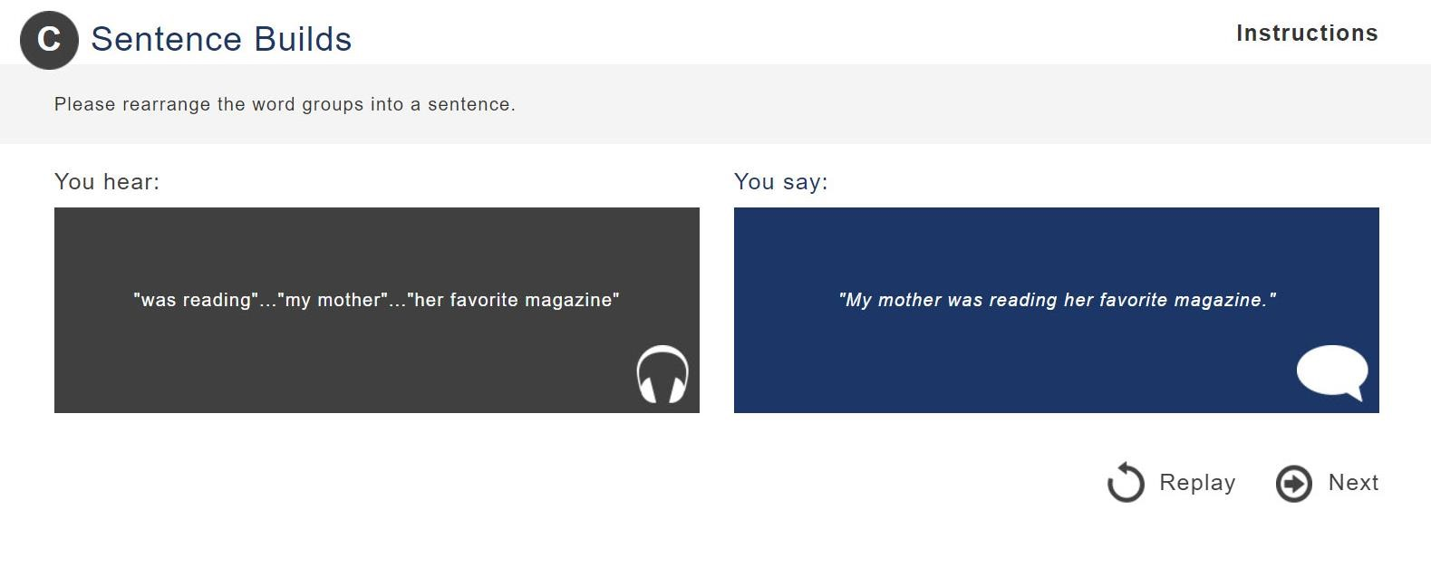

# Part D: Conversations

|  |  |  |
| --- | --- | --- |
| **Task Description:**  Listen to a conversation between two speakers and then answer a comprehension question.  **Number of questions:** 12 |  | **Example**  Speaker 1: Congratulations on graduating!  Speaker 2: Thanks! It was a lot of work.  Speaker 1: I know. You deserve a party.  Question: Why does the man deserve a party?  **Time allotted:** 2 minutes |

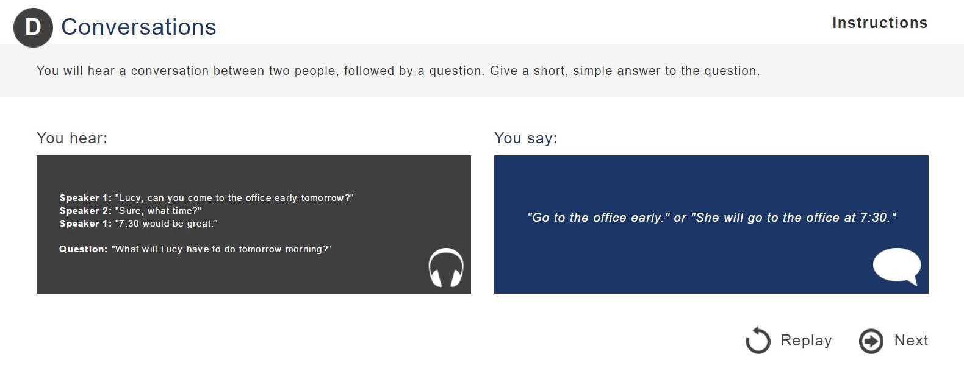

# Part E: Typing

|  |  |  |
| --- | --- | --- |
| **Task Description:**  Type a given passage exactly as displayed in 60 seconds. This is an assessment of typing speed and accuracy and allows you to familiarize yourself with the keyboard  **Number of questions:** 1 |  | **Example**  Many people do not like public speaking. They are afraid to speak in front of a large group of people.  There are many ways to get better at public speaking. First, it is good to know the room. You should know where to stand and where to set up your computer…(etc.)  **Time allotted:** 1 minute |

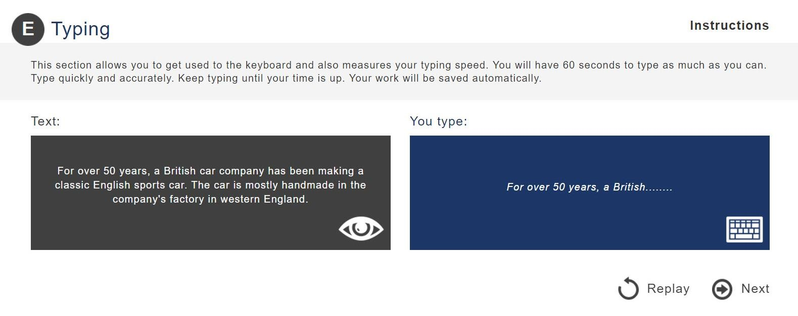

# Part F: Sentence Completion

|  |  |  |
| --- | --- | --- |
| **Task Description :**  Read a sentence that has a word missing, and then supply an appropriate word to complete the sentence.  You are given 25 seconds for each item.  **Number of questions:** 20 |  | **Example**   1. Her favorite hobby is _________. She has so many books. 2. He arrives __________ and is often the first one here. 3. I asked a coworker to take over my __________ because I wasn’t feeling well.   **Time allotted:** 8 minutes |

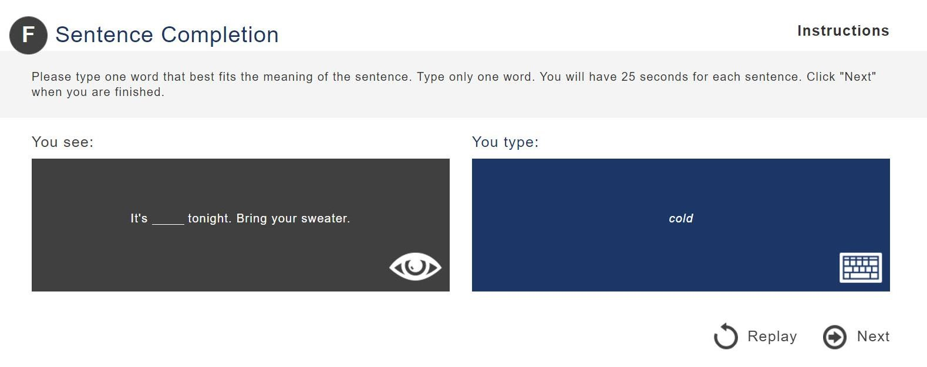

# Part G: Dictation

|  |  |  |  |
| --- | --- | --- | --- |
| |  | | --- | | **Task Description:**  Listen to a sentence and then type the sentence exactly as it is heard.  You are given 25 seconds for each item.  **Number of questions:** 16 | | |  | | --- | | **Example**   1. I’ll see you on Thursday. 2. How long can I keep this book? 3. She apologized to all her friends several times.   **Time allotted:** 7 minutes | |

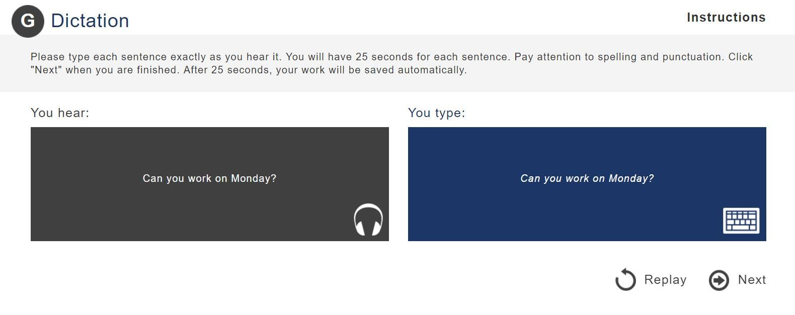

# Part H: Passage reconstruction

|  |  |  |
| --- | --- | --- |
| **Task Description:**  Read a short paragraph for 30 seconds. After 30 seconds, the paragraph disappears.  Then, reconstruct the paragraph in 90 seconds, including the main points and as many details as possible.  **Number of questions:** 3 |  | **Example**  Robert went to a nice restaurant for dinner. When the waiter brought the bill, Robert reached for his wallet, but it wasn't in his pocket.  He remembered having his wallet when he came into the restaurant. The waiter looked around the floor near his table. He found the wallet under the table.  **Time allotted:** 6 minutes |

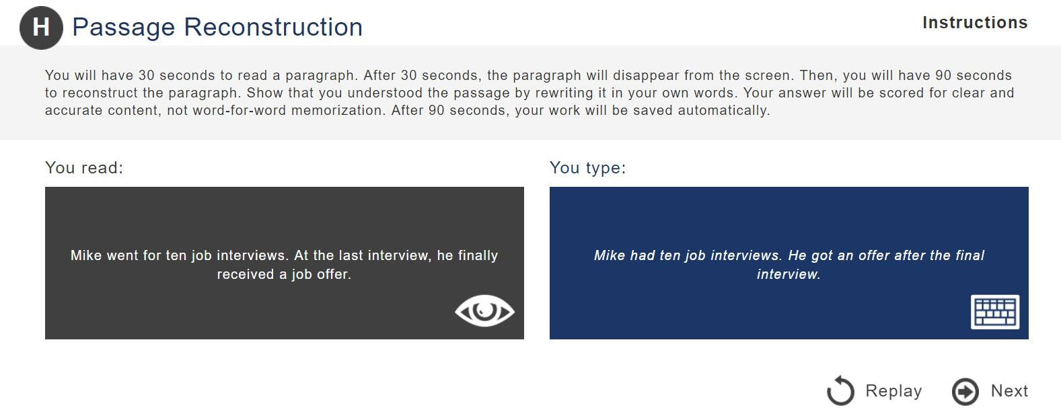

# Part I: Summary and opinion

|  |  |  |
| --- | --- | --- |
| **Task Description:**  Read a passage. Then, write a summary of the author’s opinion in 25-50 words and give your own opinion on the topic presented in the passage in at least 50 words.  You are given 18 minutes to read the passage and write both responses.  **Number of questions:** 1 |  | **Example**  Some children grow up in a big city while other children grow up in the countryside. Childhood experiences can be very different depending on where a person is raised.  Although the countryside can be more peaceful than a big city, it is better for children to grow up in a big city…(etc.)  **Time allotted:** 18 minutes |

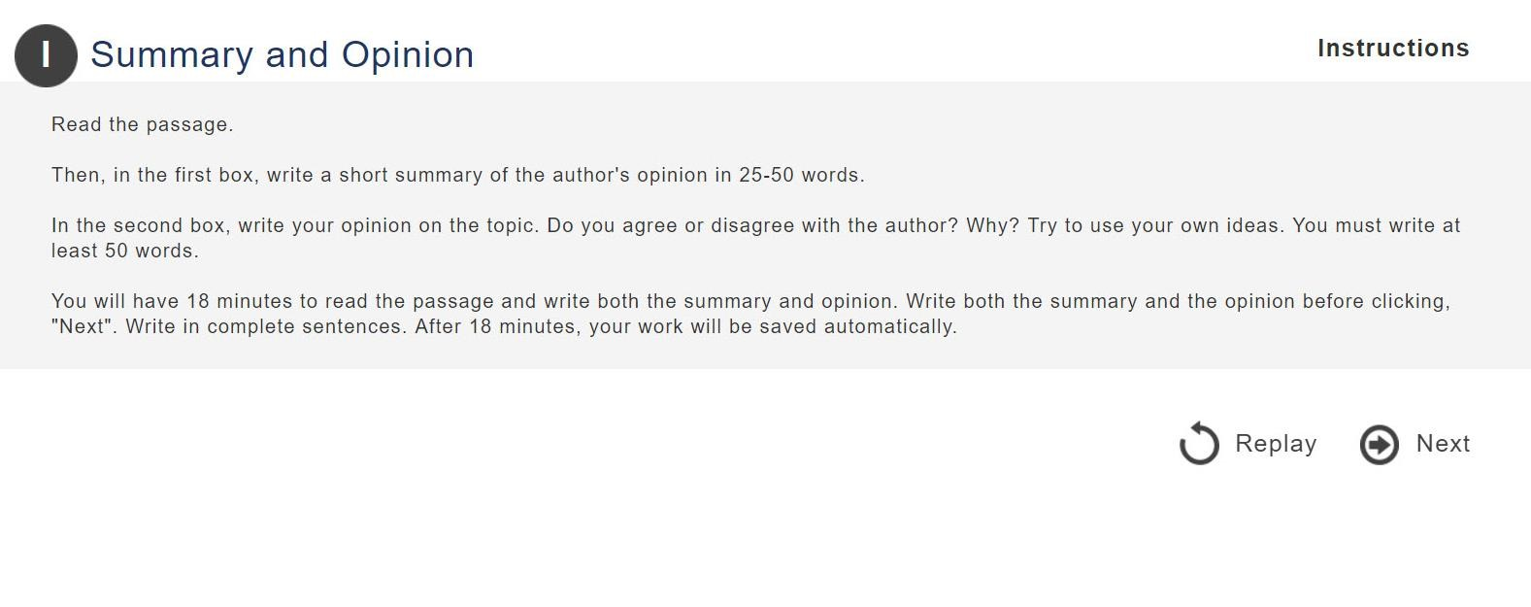



## About Deloitte

Deloitte refers to one or more of Deloitte Touche Tohmatsu Limited, a UK private company limited by guarantee (“DTTL”), its network of member firms, and their related entities. DTTL and each of its member firms are legally separate and independent entities. DTTL (also referred to as “Deloitte Global”) does not provide services to clients. In the United States, Deloitte refers to one or more of the US member firms of DTTL, their related entities that operate using the “Deloitte” name in the United States and their respective affiliates. Certain services may not be available to attest clients under the rules and regulations of public accounting. Please see [www.deloitte.com/about](http://www.deloitte.com/about) to learn more about our global network of member firms.

Copyright © 2017 Deloitte Development LLC. All rights reserved. 36 USC 220506